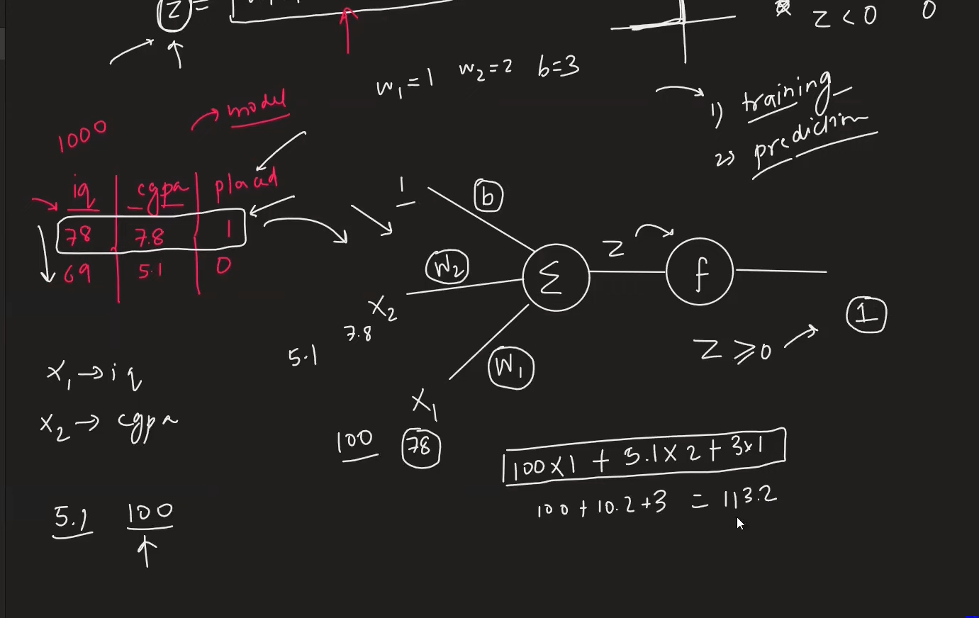
Inspired by nuerons
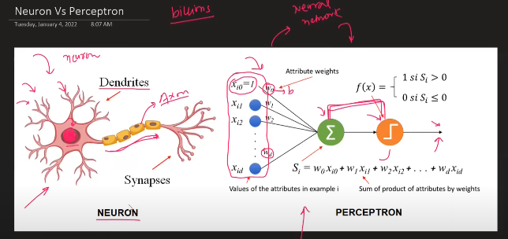
There is difference, nuerons actual is more complex
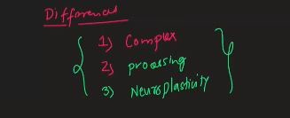
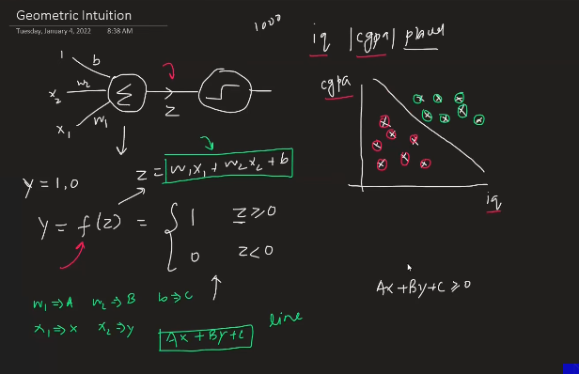
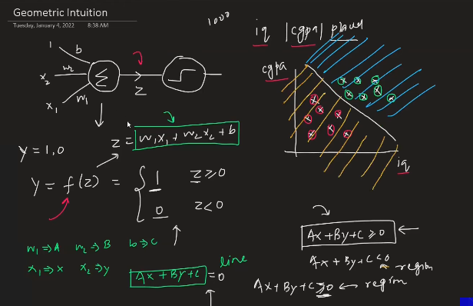
Placed are in green circle and the red circle is not placed
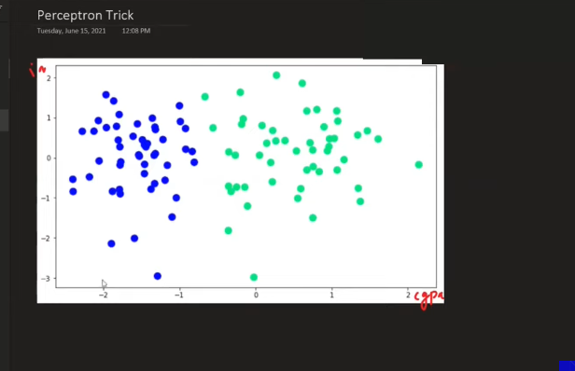
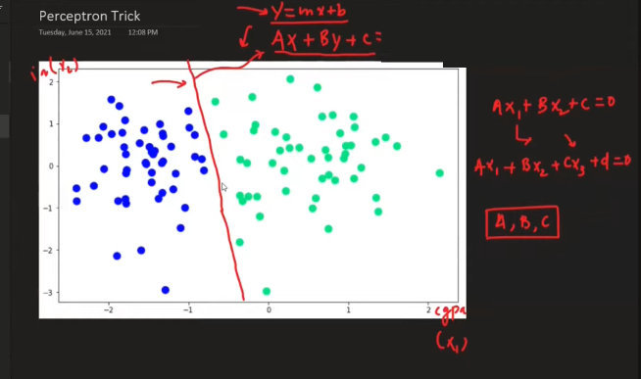
Find the values of A,B and C in such a way that, it has to make the line perfectly to seperate the regions.
Initially make the random intialization of A,B,C .
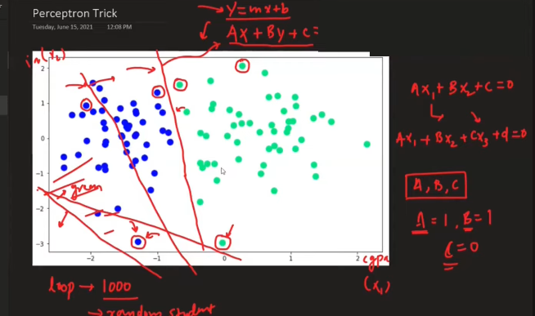
How many number of times we need to draw this line:
- Convergence
- epoch
Movement in the line depends on the value of a, b and c
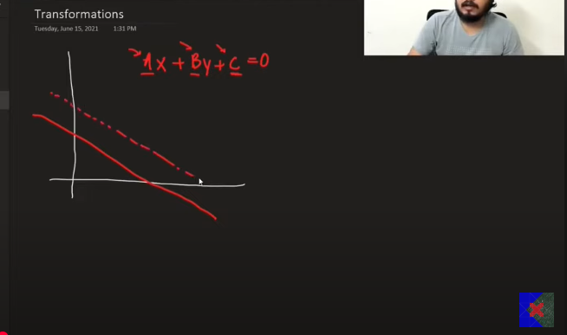
When you increase the value of C, then it will make the top line, the dotted line.
A means change in the direction on y .
B means there is change in direction x.
C transations
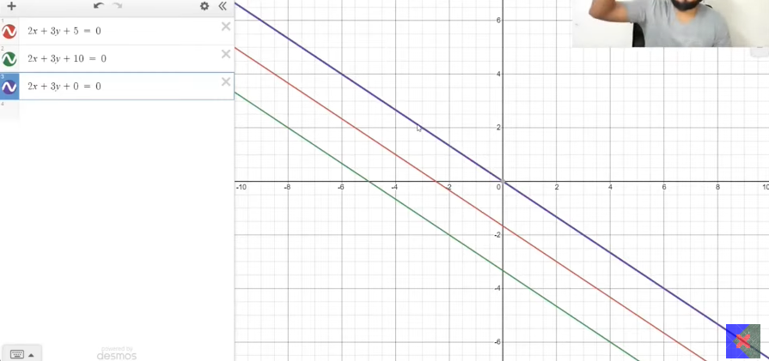

Change in A, the transition that is happening at the y intercept is going to change the directions to positves when there is increase in A.
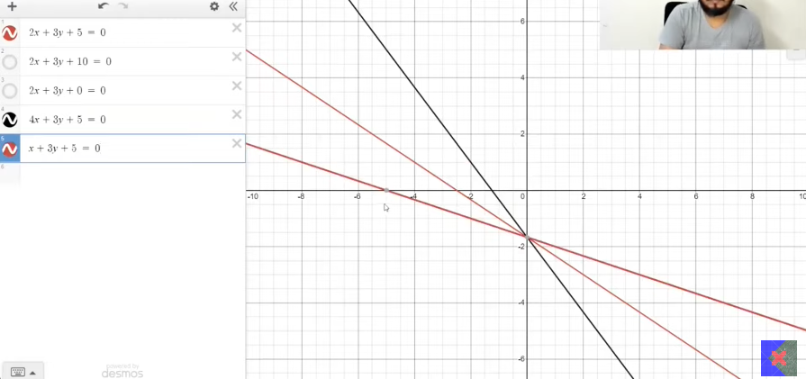
B changes
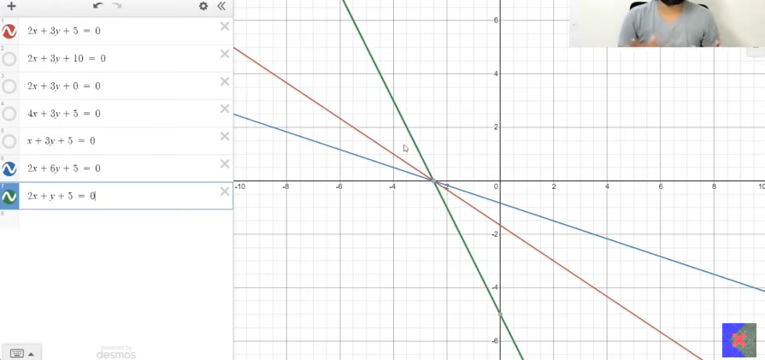
When used in combination, then there is best line.
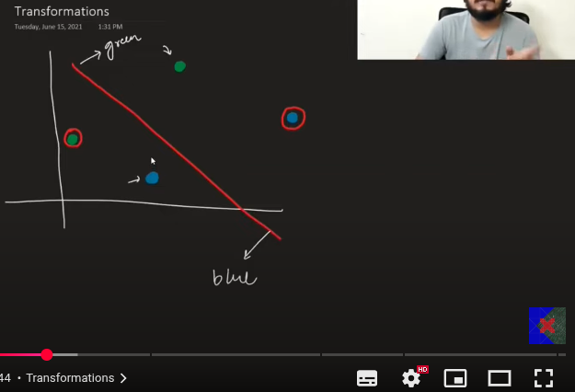

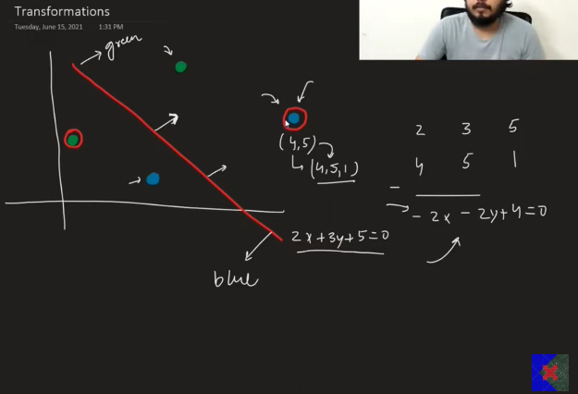
For the new equation with the -2x etc etc, the line will make the blue line negative.
Important : if the line to be moved upwards or towards the positive then we need to subtract the line equation coeff with the point in the space.
When there is need to make the line come down/ move towrds the negatie region then the you need to add the lines coeff with the point in the coordinate
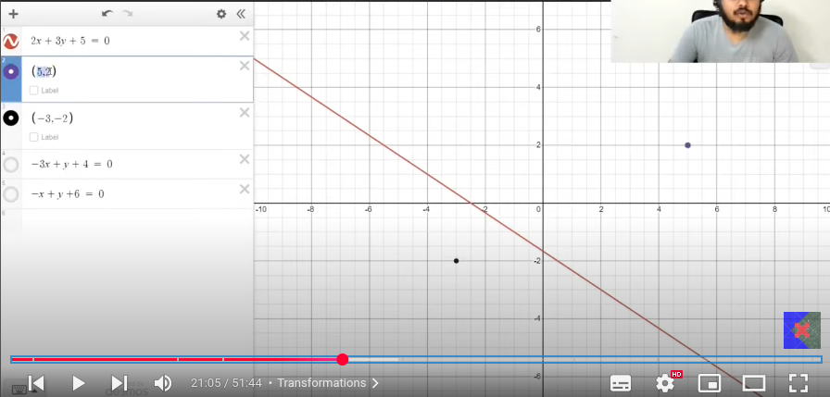
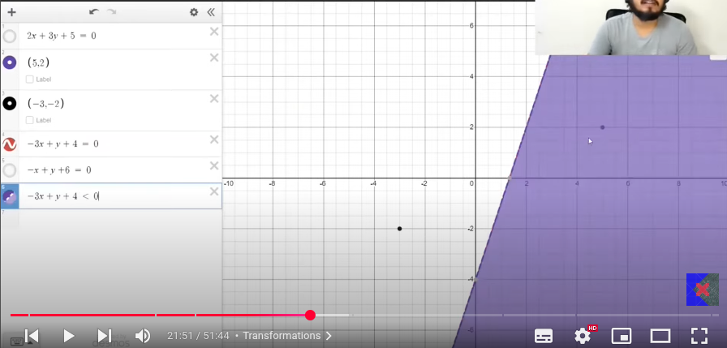
The first quedarn region at the first it was on the positive initially but it became to th enegative side after making the transition.
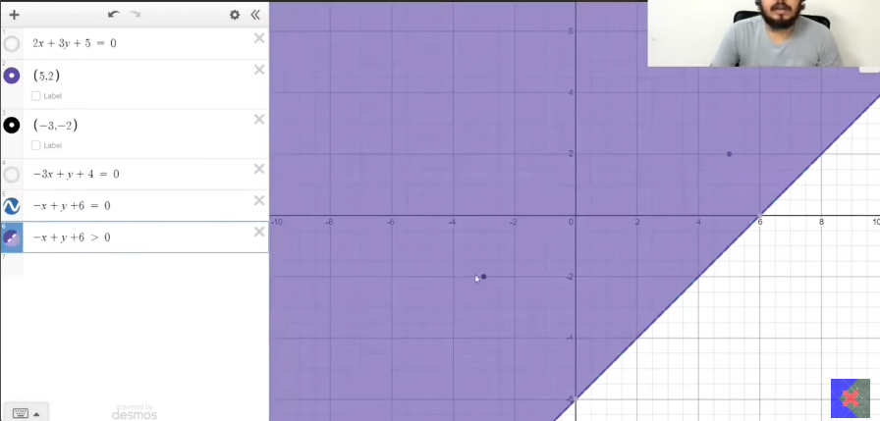
2nd trasntion
Thse kind f yransation will occur in terms of the learning rate
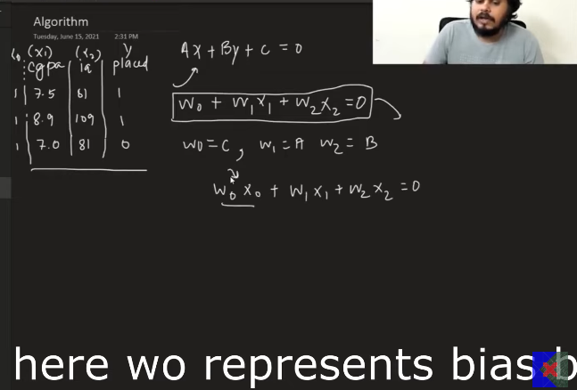
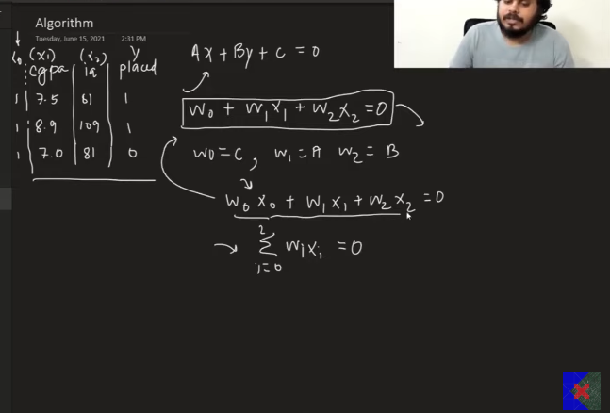
Prediction:
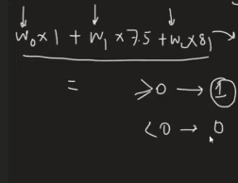
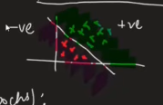
This is generated because of the line.
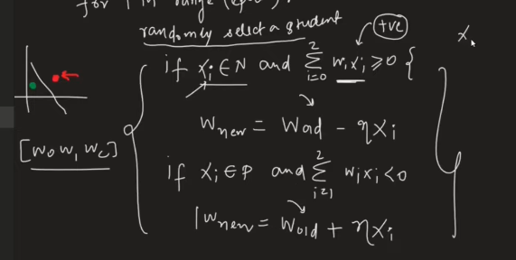

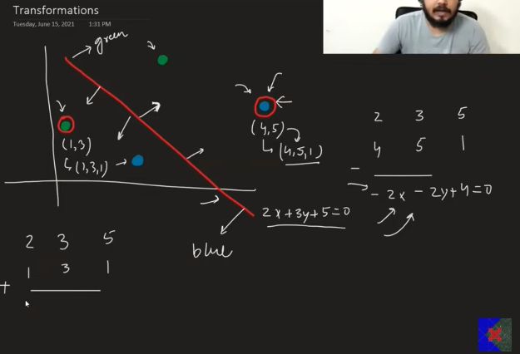

PERCEPTRON LOSS FUNCTION
- In the previous steps what we did is dot product and based on the above result we are able to bring the change in the weights and biases.
- But that is not the right way.

- Line got from perceptron trick we cannot say whether the line produced is right or wrong?
  - Even though the classification is done properly, cannot say line is correct or not, since that is found by pulling the lines to the prope direction, by mutliplication and changing the weihgt like that.
  - 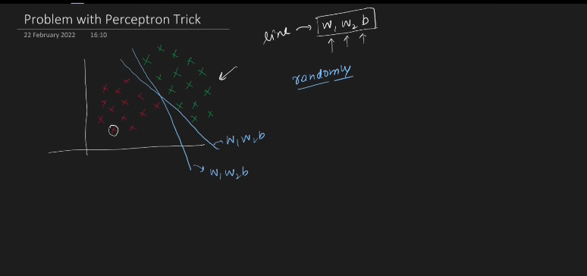
  - Anyone of the above 2 lines can be obtained using the perceptron.
  - Cannot quantify: Because in this we cannot quantify the loss produced is how much loss is produced by each correct classified line cannot say.
  - Cannot converge: Thousands point considered randomly , may not sure only the different points are considered, can always be the the same set of points can be consider for making the line right? This is also possible.
    - If it is converged, we cannot say the line obtained is the best among all. Quantifying is possible.
- Loss function : It is the way to tell whether model is performing properly or not.
  - Loss function gives value to each and every line.
  - The one with the lesser loss value line is chosen as best.
- Finalizing the loss function for the perceptron
  - Number of misclassified points by the line– this can also be one loss function ,based on the new line generated.
  - Absolute Distance between the line with summation of all the mis-clasifed points.
    - Make the perpendicualr distance
    - 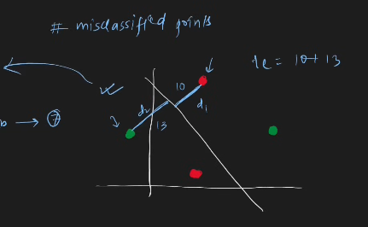
    - This calculates the perpendicular distance between the point and the line. Finally the summation of these all the perpendicular line is maintained.
    - This is far better then previous, it not only says regarding the number of misclassified point, but also tell about how much value has been misclassified.

  - Perceptron loss function:
    - Rather calculating the distance between the line and the coordinate, what I’ll do is ,
    - I’ll be considering the coordinate point x,y and making the dot product between the point and the line coordinates.
    - Finally the output came from the previous calculations, we will be adding the overall to produce the new result. That is considerd as the perceptron loss function.
    - 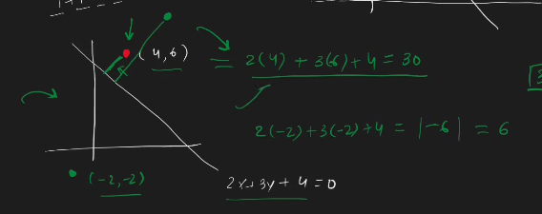
    - Because distance calculation is quite complex, but the above is just the dot product.
    - 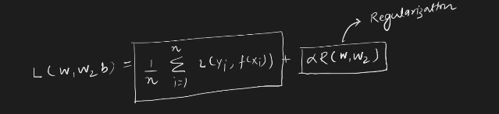
    - 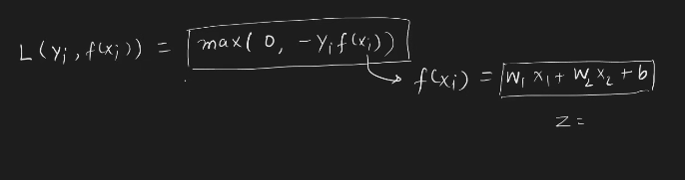
    - 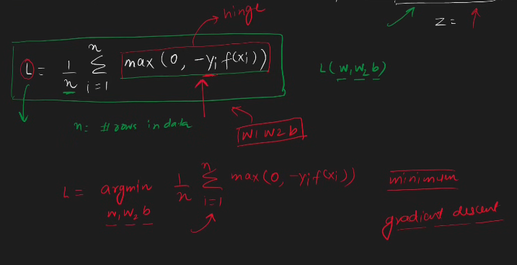
  - What is hinge loss and how does that effects.

    - https://www.analyticsvidhya.com/blog/2024/12/hinge-loss-in-machine-learning/
    - 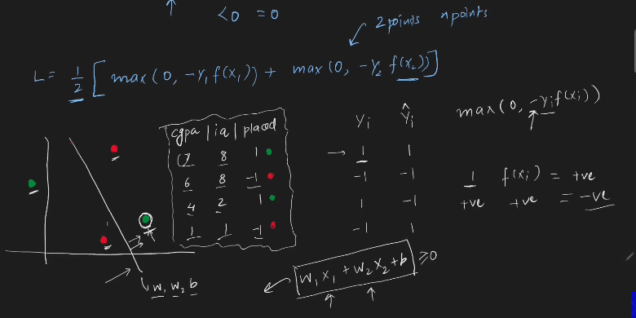
    - Trace of the data , you will get to know about it.
    - 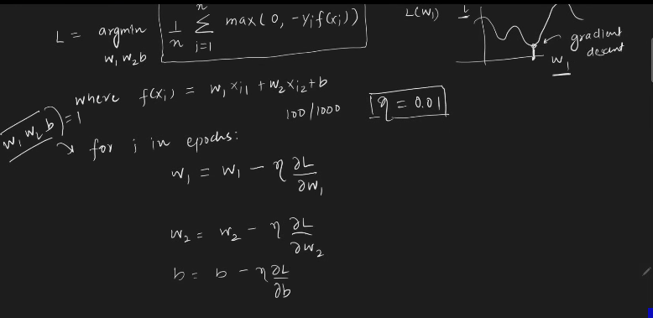
    - The loss function is not completely differentiable.
    - 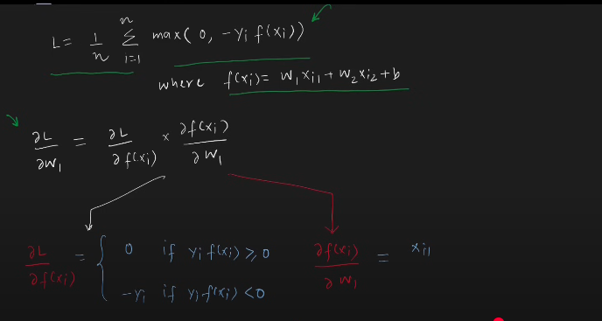
    - 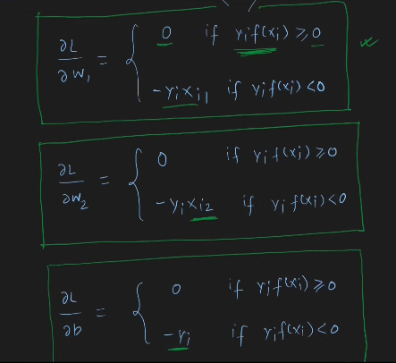
    - 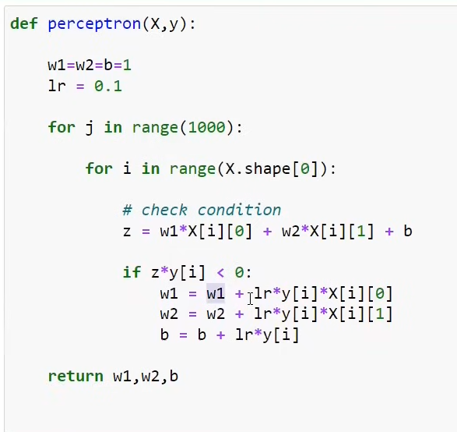

- More loss function – perceptron is a mathematical model:
  - Activation function
    - Step function[ 0 or 1, -1 or 1]
    - Sigmoid [ the value ranges between 0 and 1 ]
    - Softmax
    - Linear
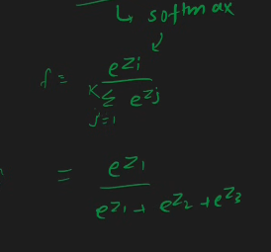

  - Loss function
    - Binary cross entropy - sigmoid
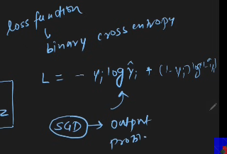
    - Categrorical cross entropy - softmax regress or called softmax - multi class classification.
    - MSE – linear(act) - regression

    - s
- If binary cross entropy is the loss function and the sigmoid is the activation function, then we can say perceptron = logistic regression.
Third column is output
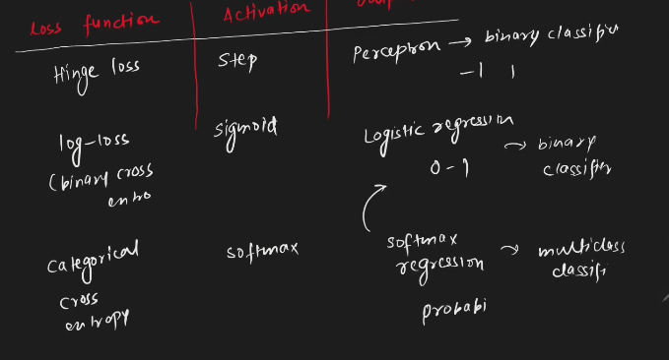

- s
MLP NOTATION:
- W(from nueron(i) ,to nueron(j), layr(k))
- B(layer , nueron)

Back propagation
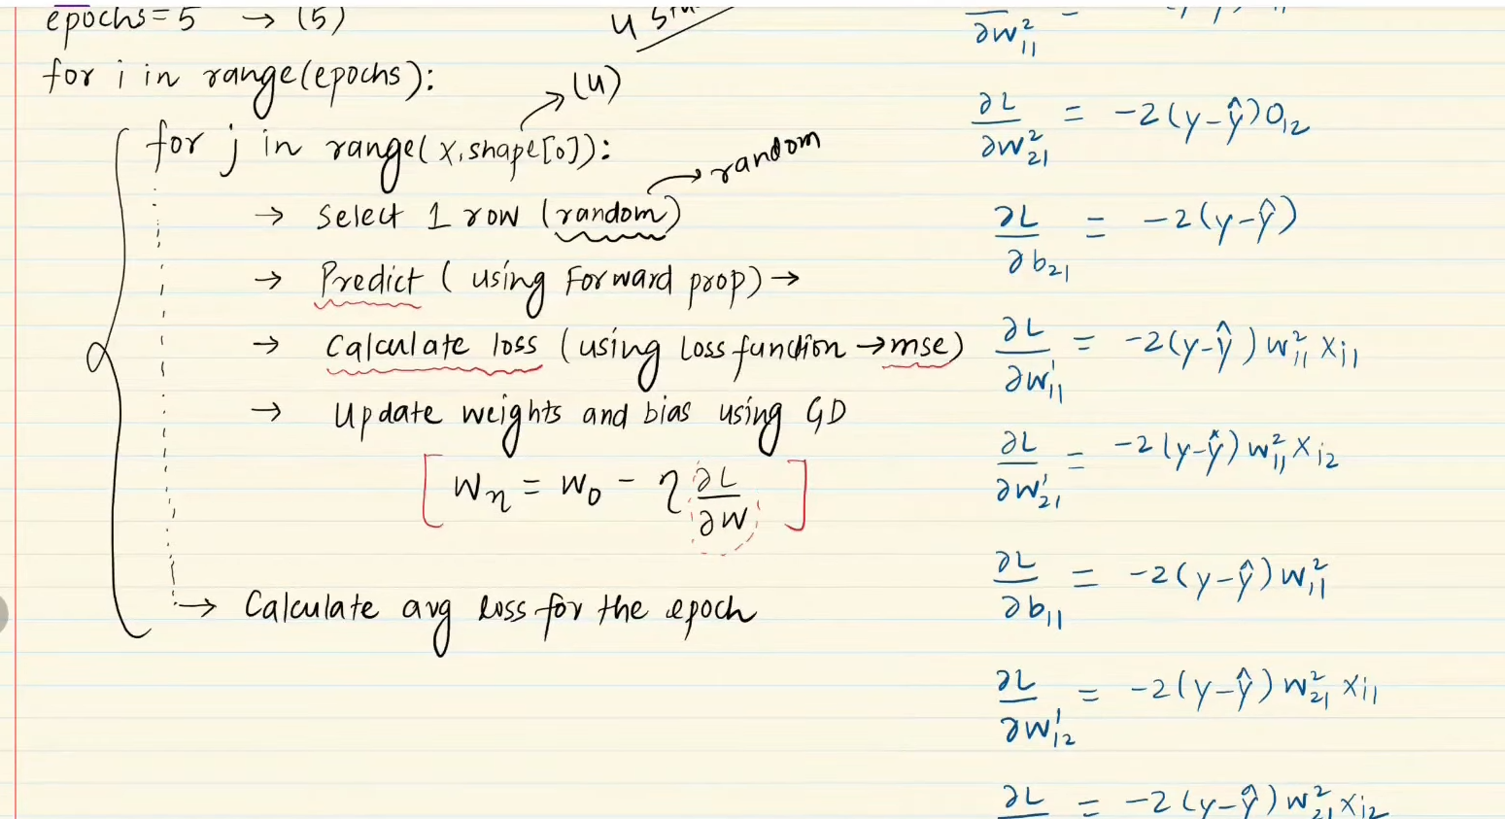

The remainning things are written in notes.

REGULARISATION

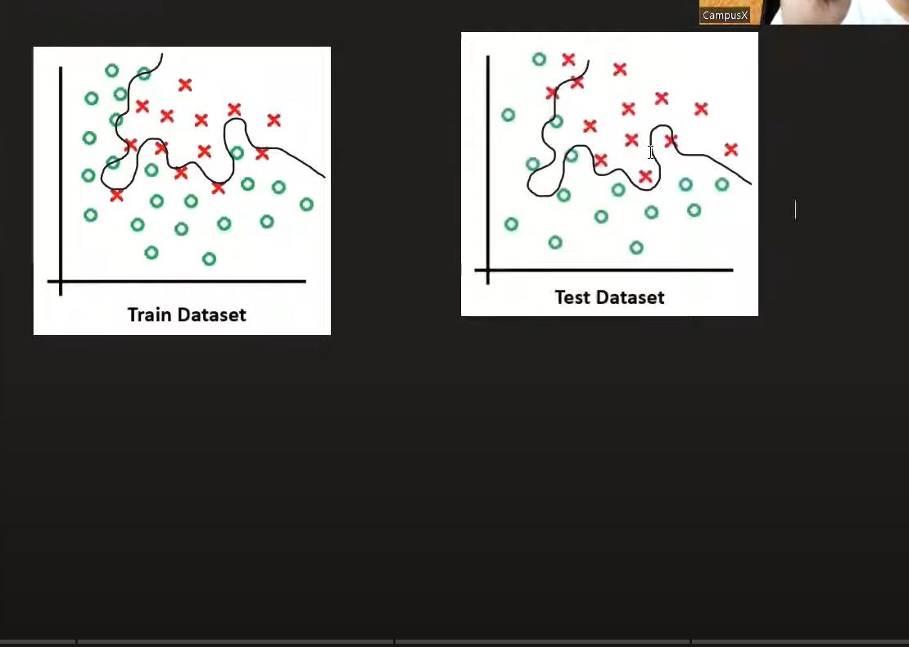
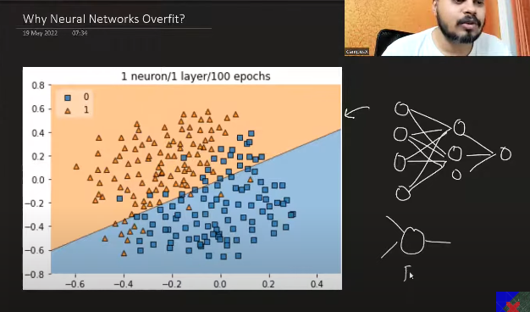
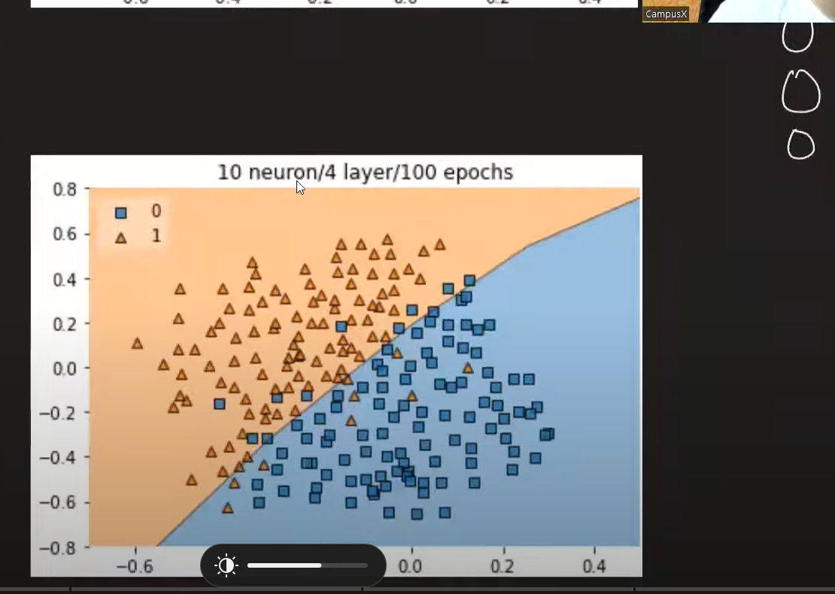
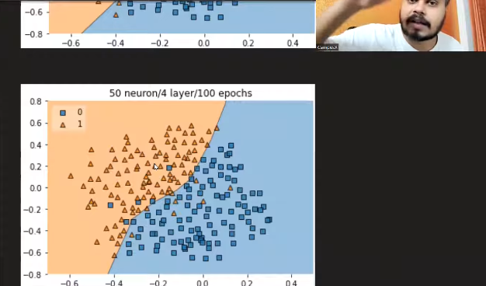
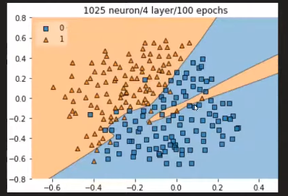

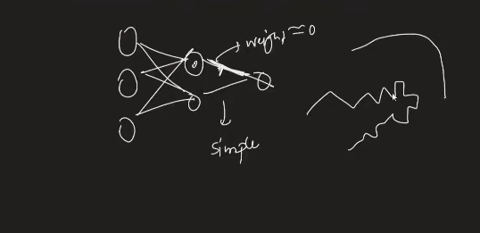

Backprop on cnn intermeiate result
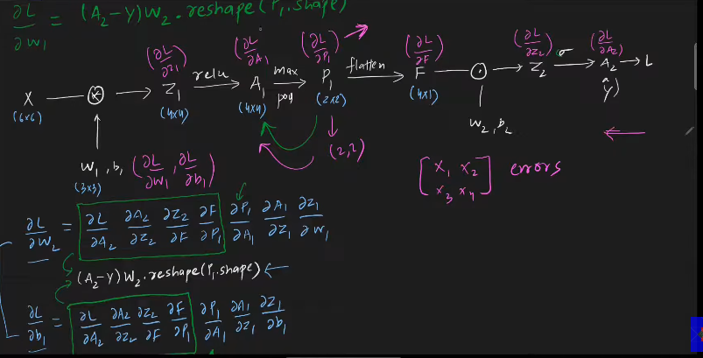
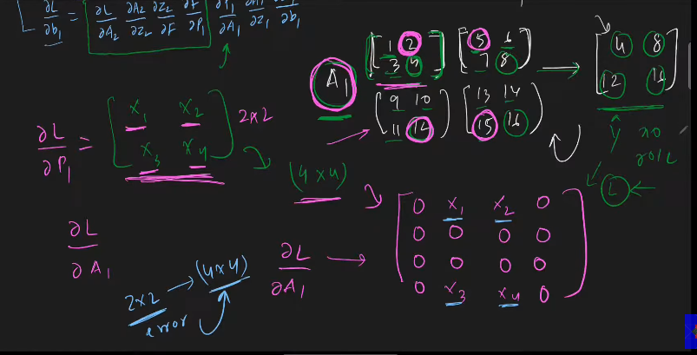

RNN

